# Roll No:. 33309 Batch- K-11

**Title:** Create Docker Container Environment (NVIDEIA Docker or any other).

**Assignment No. 2-b**

----------------------------------------------------------------------------------------------------------------------------

**Commands:**

# sudo apt-get remove docker docker-engine docker.io containerd runc sudo apt-get update

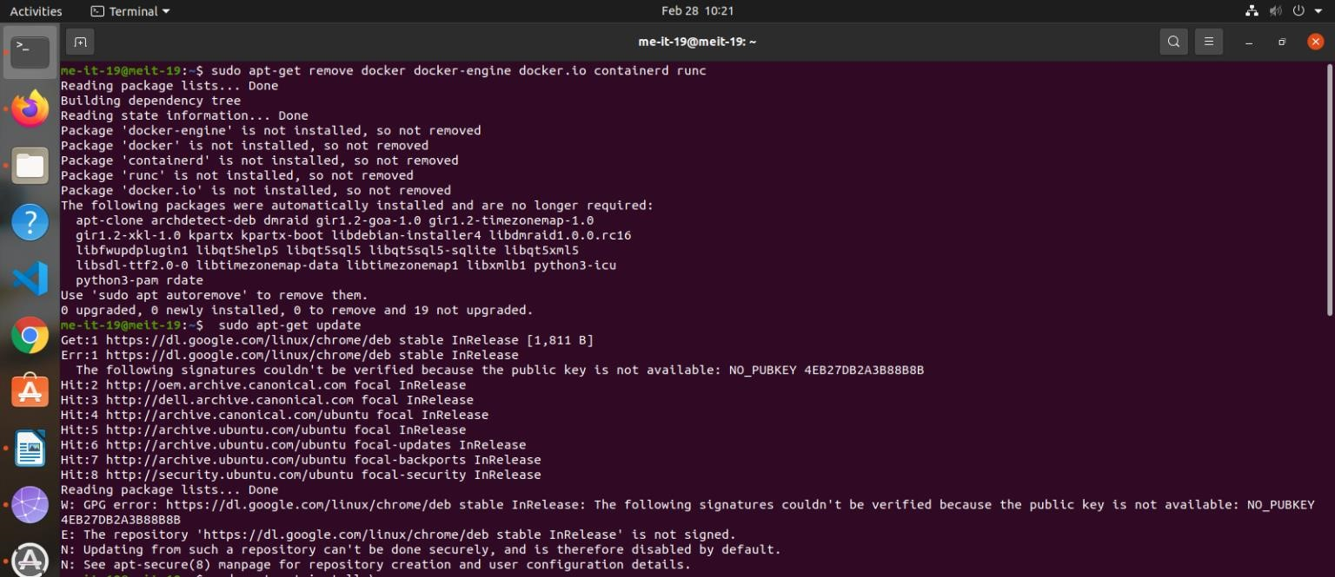

# sudo apt-get install \ > ca-certificates \ > curl \ > gnupg \ > lsb-release

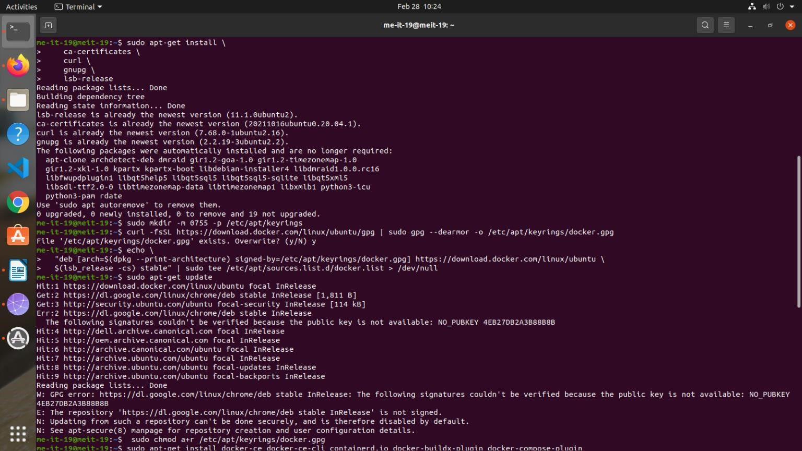

# sudo docker run hello-world

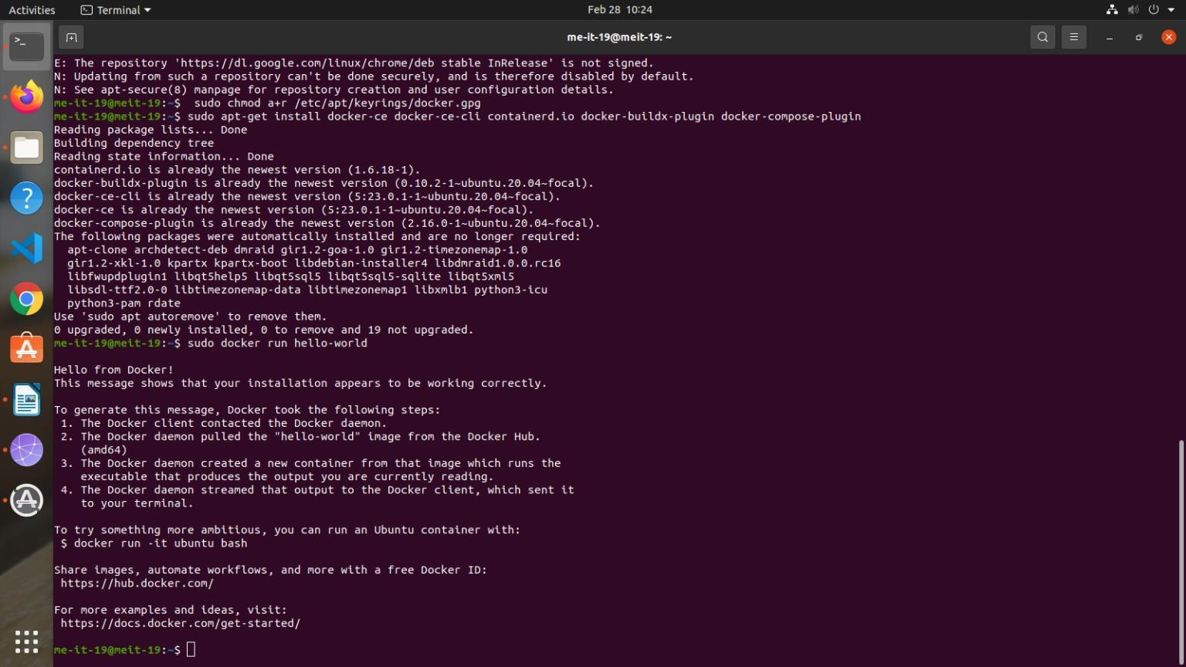

# sudo systemctl status docker

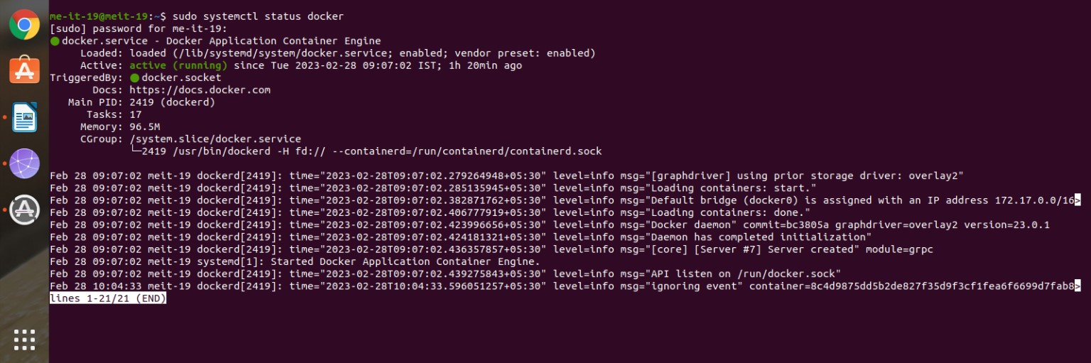

# Working with Docker Images

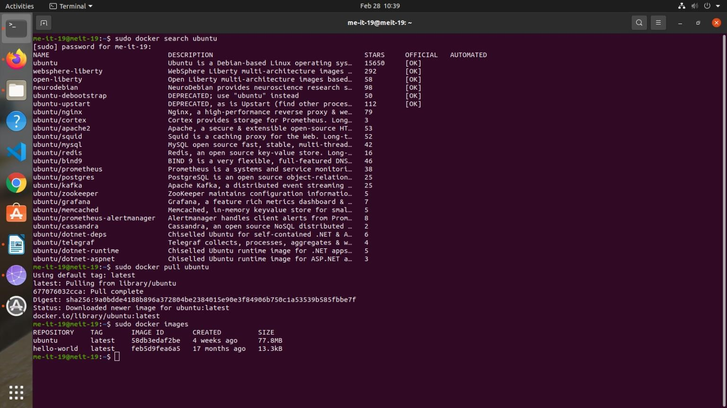

# Running a Docker Container

## sudo docker run -it ubuntu root@68cb2e3a411d:/# apt update

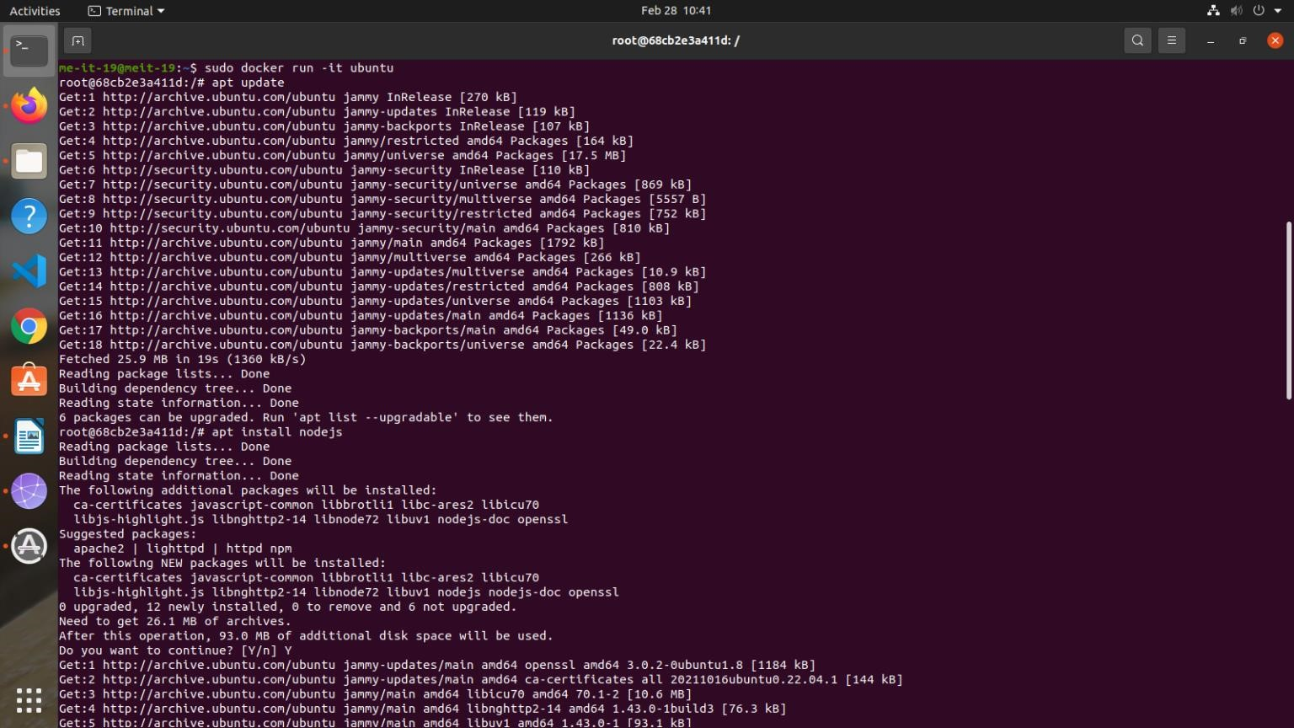

**root@68cb2e3a411d:/# apt install nodejs root@68cb2e3a411d:/# node -v**

# Managing Docker Containers

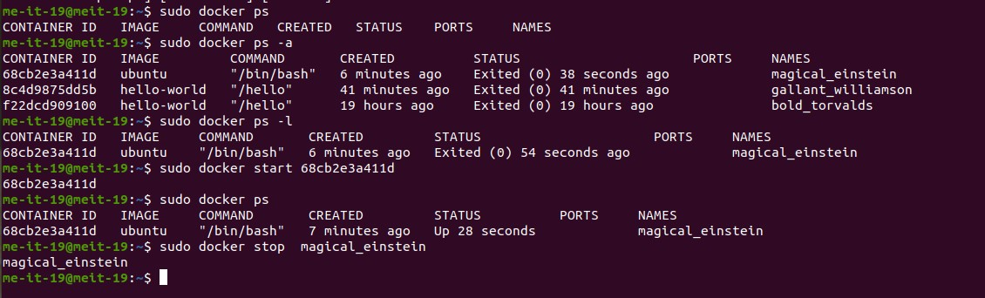

# Committing Changes in a Container to a Docker Image

## docker commit -m "What you did to the image" -a "Author Name" container_id repository/new_image_name

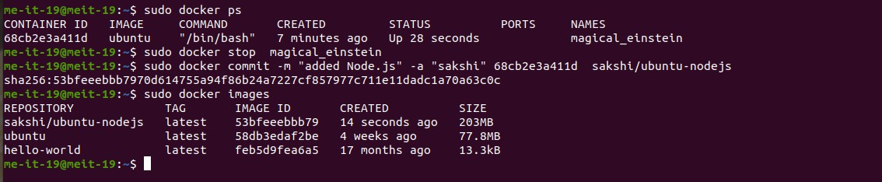

**j**